**COMP211  
PLANNING YOUR CAREER**

**REFLECTIVE PORTFOLIO**

**Name: Oliver Legg  
Student ID: 201244658**

**Contents**

Industrial Analysis 1

Application process analysis 3

Self-evaluation 4

Lecture 2 4

Lecture 4 4

Career Studio 4

Appendices 5

Appendix A - IBM Application Form 5

Appendix B - Ivanti Cover Letter 8

Appendix C – CV (Up to date) 9

Appendix D – CV (Before Careers studio) 12

Appendix E – COMP221 Sessions 14

Appendix F – Skills Audit 16

Bibliography 20

# Industrial Analysis

At University of Liverpool, I am studying Computer Science /w Software Development /w Year in Industry. I will be applying for jobs for 12-month placements focused around topics that I am good at and interested in. As my modules have been relevant to software programming in Java, I want to be primarily looking for applications that specialises towards this. I have also been driven towards other languages in previous levels of academia. Curiosity has led me to other languages that I use more than once a week including Python, Lua and C++. I have an interest towards games development and like to do it in my spare time. Because of this, I will also be applying for companies that develop games with my job being video game programming.

I researched a typical careers path for a programmer would carry out like so: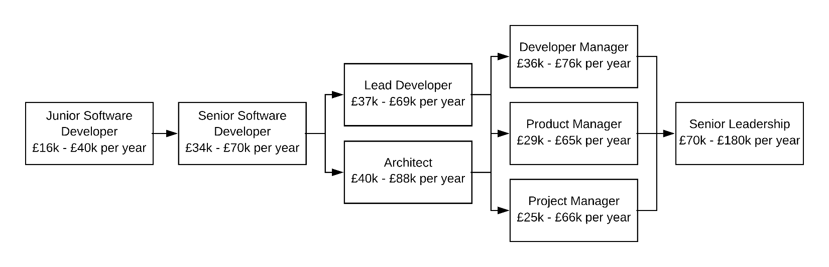

Carlson, L., 2014. *Career Path of a Programmer.* [Online]   
Available at: https://www.ctl.io/developers/blog/post/career-path-of-a-programmer/  
[Accessed 13 May 2014].

The salaries in the source provided are from America and is irrelevant to my research. Average job salaries in the image were provided from [www.payscale.com](http://www.payscale.com), [www.indeed.com](http://www.indeed.com) and [www.glassdoor.com](http://www.glassdoor.com).

Despite being driven towards job security and satisfaction, it’s still important to look at job salary and the career path that I could be going down in employment after university. The career path progresses in more responsibility and leadership roles in the future – which is something useful to keep in mind – and would be something that I would enjoy doing. The salary numbers gathered are all around the UK in cities and out of cities. The jobs in the cities pay more while cities. Jobs in areas with cheaper living costs pay less.

If I wish to progress, I need to adopt more skills in management. A great start to my career would be a junior software developer – which requires around 0 to 3 years of work experience. The other roles in this career path would require more experience of four or more years generally on jobs sites.

On [www.ratemyplacement.com](http://www.ratemyplacement.com) you usually get £16k - £25k per annum for a placement year job. Depending on the scale of the company and how technology oriented that company is, they might offer more jobs tailored towards me. A large company like 3M offers one job relevant to me which is titled ‘Software Placement’ and has the following skill requirements:

* Hands on experience with software engineering with an interest in AI, Computer Vision and Machine Learning.
* Experience with Python, C++ and C#
* Experience with Git or AWS is desirable
* Experience with Data Analytics, data cleaning and manipulation tools desirable

3M, 2018. *Software Placement at 3M.* [Online]   
Available at: https://www.ratemyplacement.co.uk/jobs/17701/3m/software-placement  
[Accessed 01 September 2018].

Unfortunately, I don’t have experience in machine learning or computer vision, so I would have to learn this in my own time to apply here.

For future reference and to be more employable, I need to gain the skills that are in the skill gap. A study was released which showed JavaScript, to be mentioned in 42% of job vacancies with Java being 30%, C# 25% and Python 19%. Perhaps I could learn JavaScript to be more employable

Grady, A., 2018. *Programming Languages: Vacancies increase by 4% as JavaScript tops the wish list for recruiters.* [Online]   
Available at: https://joblift.co.uk/Press/programming-languages  
[Accessed 26 July 2018].

# Application process analysis

In this section I will be analysing two companies that I have applied for. Those companies selected will be IBM and Ivanti. I applied to IBM through [www.ratemyplacement.com](http://www.ratemyplacement.com) and applied to Ivanti via email. I got the email from a University of Liverpool careers fair. The application process is quite different but somewhat similar. IBM has a series of processes sequentially. In the following order you go from:

* Initial Application (CV)
* IPAT Test
* Video Interview & Application Form
* Assessment Centre
* Final Interviews

IBM assessment centre contains team building exercises and staff watch how you perform on and how you interact with others. We would also be made to do a presentation about a technology that we’re fascinated about to peers. IBM’s application process is much longer than Ivanti’s. Ivanti’s process works like so:

* Initial Application (Cover Letter /w CV)
* Assessment Centre

Ivanti’s assessment centre consists of an interview, team building and a problem-solving competency test.

IBM is a colossal company and will have hundreds of applicants. They will decline many people on the initial application, many won’t pass the test and won’t necessarily pass the assessment centre. This cuts down the number of applicants massively. As Ivanti is medium sized organisation, it would have less applications and won’t require as many application steps.

The differences in the organisations changed my approach slightly. When I applied for IBM, I was addressing the company, not so much the members of it. Find IBM application form on **Appendix A**. When I applied for Ivanti, I addressed my cover letter to Andy Jackson. He was the employee who was hiring students. Find Ivanti cover letter on **Appendix B**. Usually I would send different CV’s to companies, however, with Ivanti and IBM, I didn’t need to change it because both organisations required the same key skills and I was applying for the same job title – Software Developer. My CV can be found on **Appendix C**. With my application to Ivanti I was able to show that I have done research about the organisation. All the annotation found on the appendices have been learnt in the lecture slides.

# Self-evaluation

COMP211 provided me with a lot of skills this semester. I am massively satisfied with the module and will be evaluating my learning outcomes. I developed these skills from the information provided in lectures and advice from previous applicants on their year in industry. I will give an overview of the lectures I found most helpful and how those lectures helped to develop skills.

## Lecture 2

This was one of my favourite lectures as it gave me an overview of the lecture given from applicants. It’s interesting to see other student’s effort and attitude towards their applications. They elaborated on their experiences and gave tips on how to be more employable. Specifically, Harrison Tse applied for competitive placements at Google and JPMorgan and has received placement offers at Amazon and PwC. Harrison explained the types of skills that major and minor organisations like to see that we can instantly improve - including LinkedIn, GitHub etc. The Q & A in the lecture was extremely helpful as we were able to put to rest questions to placement students. A student asked a question which was asking where the placement students applied for their jobs. The common answer was [www.ratemyplacement.com](http://www.ratemyplacement.com). I have used this a lot myself and is an extremely useful website. Overall, hearing about other people’s experiences and their thought process when they faced a problem was helpful to hear because we could know how to prevent problems, make applications easier and more successful.

## Lecture 4

One of the most useful lectures that I refer to in my spare time when applying for companies is this. The lecture teaches us that we should tailor each CV and cover letter to the company. This is very helpful as I can follow tips, rules and recommended formatting for applications. I was able to be clear, coherent and professional to my employers. For the cover letter, it was helpful to sort the formatting like so: Introduction; Why I chose the company; Why I chose the role; Why they should pick me; then signing off. This is useful to follow, and I have used this with my applications. The lecture slides also contained a section based on personal statements which has helped me for my application to IBM.

## Career Studio

The career studio has been extremely helpful with my CV (my old CV can be seen in appendix D. I came into the career’s studio with a pen, paper and a printed copy of my CV and was helped by staff to correct my CV within minutes. With help from the staff, I was advised to widen my page margins to fit more content on my CV, increase organisation, spot spelling and grammatical errors. My lectures taught me how to make a good CV, but the careers studio was able to get second opinions from professionals – which is completely worth it. From this, I have developed skills in creating CV’s and being able to spot these sorts of errors from my work.

# Appendices

## Appendix A - IBM Application Form

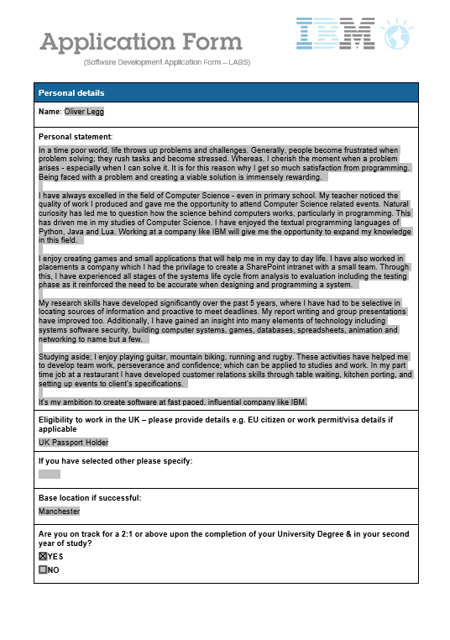

Censoring sensitive information

I used the personal statement section from the lecture 4. I used my own personal statement I had used from years ago and applied the new skills I had learnt from lectures into my work.

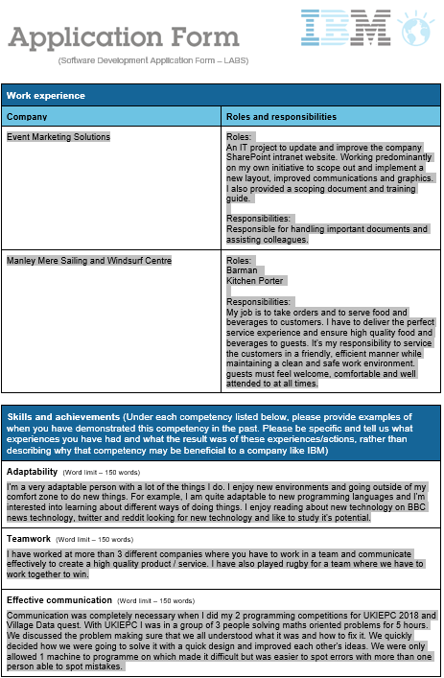

I am showing how my work experience and general experiences have benefitted me the skills shown

Added work experience, displaying key skills that are key to the job’s description

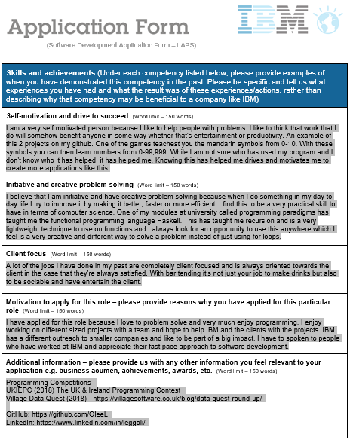

As I am applying for a programming job and it would be valuable to the employers if they knew I attend programming competitions.

LinkedIn is useful for employers to get in touch with you and is widely used. It can be useful for me to show off achievements I have made in the past

My motivation and attitude towards work is very positive.

Using tools like GitHub which shows employers that I know how to use important tools to distribute and share code to colleagues

## Appendix B - Ivanti Cover Letter

Dear Andy Jackson,

I am an undergraduate student studying Computer Science at University of Liverpool and came across your company at the University of Liverpool careers fair. I would like to apply for a Software Engineering role for a 12-month placement at Ivanti. I admire how much Ivanti has grown over years – particularly with how you have merged with other organisations.

You’ll see from the attached CV that I am a hardworking and conscientious person who has a strong interest in programming and the world of technology. A lot of the skills I have acquired through my degree and projects on the side are completely transferrable for the job. I enjoy developing software and would like my job to be something I enjoy. My most comfortable programming languages are

* Java
* Python
* Lua
* C/C++

Thank you for considering my application. I am looking forward to hearing from you. You can reach me on 07939922443 or [oliglegg@hotmail.co.uk](mailto:oliglegg@hotmail.co.uk)

Yours sincerely,

Oliver Legg

Introduction and intention and why I want to work for the company. I have also shown that I have researched the organisation

Making it easy as possible for the employer to get in touch with me (– Signing off).

Referencing CV and highlighting key skills and how they’re transferable to the job – which why I want this job

## Appendix C – CV (Up to date)

**Oliver Legg**

The Granary, Claim Farm, Manley Rd, Kingswood, Cheshire WA6 6HT

**Mobile: 07939922443 – Telephone: 01928740957 – Email:** [**oliglegg@hotmail.co.uk**](mailto:oliglegg@hotmail.co.uk)

**LinkedIn:** [**www.linkedin.com/in/leggoli**](http://www.linkedin.com/in/leggoli) **- GitHub:** [**https://github.com/OleeL**](https://github.com/OleeL)

**Summary**

I am an enthusiastic, trustworthy, conscientious and punctual person who enjoys new challenges and pushing my boundaries. I work well in a team and on my own while organizing and communicating effectively at all levels. Embracing new challenges drives me to improve myself and I am eager to learn new skills.

**Qualifications**

**University of Liverpool - (September 2017 – June 2021)**BSc (Hons) Computer Science /w Software Development /w a Year in Industry  
  
Year 1: 68% 2:1  
Modules: Programming Language Paradigms; Graduates for the Digital Society; Data Structures and Algorithms; Foundations of Computer Science; AI; Analytical Techniques for Computer Science; Object Oriented Programming; Computer Science.  
  
Year 2: 72% 1st (expected)  
Modules: Software Engineering I; Database Development; Computer Networks; Data Science; Group Software Project; Planning Your Career; Software Development Tools; Cyber Security; Principles of C and Memory Management;

**Helsby High School/Sixth Form - (September 2010 – June 2017)**Helsby High School: 7 GCSE’s including Maths, English and Computer Science  
Helsby Sixth Form: 3 A Levels: Computer Science

**Experience**

**Tokyo Noodle Bar – Waiter – (September 2018 – Present)**  
Table waiting has helped me massively to develop my communication with customers and how to multitask and perform in high pressure situations. Additionally, the cultural learning experience has been enormously intriguing and has helped my learning rate for mandarin massively.

**Manley Mere Sailing and Windsurf Centre – Kitchen Porter/Barman – (December 2016 – April 2017)**Working in the kitchen and bar in a varied role enabled me to develop my customer service skills and understand theservice industry better.

**The Goshawk, Pub – Kitchen Porter – (September 2016 – December 2016)**  
Working as a Kitchen Porter in varying shift patterns I had to communicate with other kitchen and waiting staff to deliver a fast and efficient service.

**Event Marketing Solution, Roadshow Company – IT Assistant – (July 2015 – August 2015)**   
An IT project to update and improve the company SharePoint intranet website. Working predominantly on my own initiative to scope out and implement a new layout, improved communications and graphics. I also provided a scoping document and training guide.

**Event Marketing Solution, Roadshow Company – Work Experience – (July 2014 – August 2014)**   
A placement in Sales and Marketing, Operations, Client Services, Finance and IT teams. This gave me an insight into how teams work together, the importance of communication and an experience of work ethics.

**Additional Information**

Programming

Programming Competitions

UKIEPC (2018) - The UK & Ireland Programming Contest

Village Data Quest (2018) - <https://villagesoftware.co.uk/blog/data-quest-round-up/>

ArduinoI have created two projects one with an RFID module and the other with a LCD. The LCD project involved wiring up and soldering an LCD display. I created a program where text would scroll in and display in different creative ways.

Video gamesI have created multiple video games and I am currently in the process of creating a level editor for a game which has been extremely enjoyable. You can find the repository for the game in development called practice_game in the love2d-lua repository on my GitHub above.

Learning Mandarin

I also built a basic program in java one evening to teach myself Chinese numbers as I couldn’t find an app, method or tool to teach myself this effectively.

Computer and 3D printer building

At a young age, I found it being more affordable to get a good quality computer if you build it yourself. I took it upon myself to learn about the components of a computer and build it myself. This interest then led me to research more about hardware – hence the reason I built my own 3D printer, designed and printed my own 3D models. Upon doing this, I have found this to improve skills such as:

* Planning
* Research ability
* Independence

Digital Currency Society

I am currently a member of the University of Liverpool cryptocurrency society. I am taking a lot of skills away from this from attending conferences and communicating with people around me. The society offers lessons on how to trade and how different coins and the blockchain works. This has taught me:

* Risk management
* Seizing the opportunity

Driving License

I hold a full, clean license obtained in 2017

Sports

* Running
* Cycling
* Rugby
* Calisthenics

**References**

Mr Nicholas Sloka, System Development Manager, Event Marketing Solutions   
**Tel:** +44 (0)151 350 1500 **Email:** [nick.sloka@eventms.com](mailto:nick.sloka@eventms.com)  
Dr Vitaliy Kurlin, Academic Adviser & Lecturer, (Computer Science dept.), University of Liverpool   
**Website:** kurlin.org **Email:** [vitaliy.kurlin@gmail.com](mailto:vitaliy.kurlin@gmail.com)

***References are available on request***

## Appendix D – CV (Before Careers studio)

Oliver Legg

The Granary, Claim Farm, Manley Road, Frodsham, Cheshire WA6 6HT

01928740957 • +447939922443 • [oliglegg@hotmail.co.uk](mailto:oliglegg@hotmail.co.uk) • <https://www.linkedin.com/in/oli-legg-0a1073115/>

**Personal Profile**

I am an enthusiastic person with a strong interest in computer technology which leads me to pursue my degree of Computer Science at University of Liverpool. I have completed two months of work experience at Event Marketing Solutions. This has helped me to gain experience in a real life office environment, obtaining skills I wouldn’t acquire in education. From gaining this experience, I have learnt I wanted to pursue a career in Software Development.

**Key Skills**

* Main knowledge of programming languages in Python, Lua and Haskell
* Experience with running and building servers
* Highly adaptable, and able to pick up new systems quickly and efficiently
* Communicating as a team effectively

**Employment History**

Manley Mere – (Bar tending & kitchen porting)

(July 2016 – February 2017)

Achievements, skills acquired and responsibilities:

* Communicating as staff
* Quality control in the kitchen
* Outgoing personality to clients

Event Marketing Solutions – Ellesmere port (Computer technician)

(July 2014 – 2 weeks)

(July 2015 – 3 weeks)

(August 2016 – 2 weeks)

(July 2017 – 2 weeks)

Event marketing solutions

] design and manage a fleet of roadshow trucks

Achievements, skills acquired and responsibilities:

* Helping develop an intranet for their company. I supported the IT team by resolving problems that they face on a daily basis.
* Communicating with people around the office and working independently
* Problem solving
* Using initiative
* Completing work in a certain deadline

Goshawk Pub / Restaurant – Mouldsworth (Kitchen Porter)

(June 2015 – January 2016)

Achievements, skills acquired and responsibilities:

* Maintaining a high productivity rate
* Working against time
* Initiative
* Communication and teamwork
* Working against time

**Education**

Helsby High School (6th form)

(September 2015 – June 2017)

**A-levels:**

* Computer Science – D
* BTEC Edexcel Level 3 Diploma in Information Technology (double award) – D*
* BTEC Pearson Level 3 Diploma in Engineering D*

**Helsby High School**

(September 2011 – June 2015)

7 GCSEs, grade A-C, including Maths and English

**Hobbies & Interests**

I am a very musical person and appreciating all genres of music. I used to play guitar in a band which helped me to work collectively as a team. Despite my interest in music, my main interest is in computers. I have programmed multiple video games in Lua, Python and Pascal. Along with this I have built my own computer, 3D printer and server computer with a co-worker.

**References**

Nicolas Sloka – [nicholas.sloka@eventms.com](mailto:nicholas.sloka@eventms.com) (Systems Development Manager)

## Appendix E – COMP221 Sessions

|  |  |  |
| --- | --- | --- |
| Session | Present | How the session helped me |
| Session 1 Introduction | No | I didn’t attend this session. |
| Session 2 Meet past placement students | Yes | This was extremely helpful as it gave me an overview of the lecture given from applicants. It’s interesting to see other student’s effort and attitude towards their applications. They elaborated on their experiences and gave tips on how to be more employable. Specifically, Harrison Tse applied for competitive placements at Google and JPMorgan and has received placement offers at Amazon and PwC. Harrison explained the types of skills that major and minor organisations like to see that we can instantly improve - including LinkedIn, GitHub etc. The Q & A in the lecture was extremely helpful as we were able to put to rest questions to placement students. A student asked a question which was asking where the placement students applied for their jobs. The common answer was [www.ratemyplacement.com](http://www.ratemyplacement.com). I have used this a lot myself and is an extremely useful website. Overall, hearing about other people’s experiences and their thought process when they faced a problem was helpful to hear because we could know how to prevent problems, make applications easier and more successful. |
| Session 3 Researching employers and roles. | Yes | From the lecture, I learned that it was important when applying for the organisation that you should research them and what should be required of your role and your responsibility in the organisation. From this I was able to go into my Ivanti assessment centre and tell an employee the date that they were established! |
| Session 4 CV, cover letter and applications | Yes | This lecture was very useful. When I was drafting my CV and cover letter and applications at home, I was able to refer to the lecture notes, my written notes and slides when writing these up. I will always refer to these lectures when I am writing future CV’s. |
| Session 5 Assessment centres (by IBM) | Yes | The assessment centres lecture was very useful. It highlighted that it’s not important if you perform well or solve the problem quickly. It’s important that you communicate with your teammates to solve the problem and stay relevant. It’s important that you don’t leave people out or talk over people when doing the assessment centres. |
| Session 6 Interviews and Psychometric test | Yes | The online selection tests lecture helped me to learn a lot about what types of questions would be in the exams. This has helped me in interviews so that I could expect what they are going to ask. I knew what answers the employers wanted to see and what they don’t want to see. Something that I should improve on is non-verbal behaviour. I.e. eye contact, confidence and posture. I found it interesting that 55% of impressions are visual. |
| Session 7 Technical interviews | Yes | Village software came in to show one of their technical interview questions – which was fun to complete. It was interesting for them to reveal its not necessarily important whether we get it right or not – its how you try and work it out. |
| Session 8 Networking with prospective employers | Yes | This taught me how connecting with employers with LinkedIn is important. Because of this, I have received applied to a job offer in Singapore from LinkedIn. |
| Session 9 Careers Studio | Yes | The career studio has been extremely helpful with my CV (my old CV can be seen in appendix D. I came into the career’s studio with a pen, paper and a printed copy of my CV and was helped by staff to correct my CV within minutes. With help from the staff, I was advised to widen my page margins to fit more content on my CV, increase organisation, spot spelling and grammatical errors. My lectures taught me how to make a good CV, but the careers studio was able to get second opinions from professionals – which is completely worth it. From this, I have developed skills in creating CV’s and being able to spot these sorts of errors from my work. |
| Session 10 Assessment of placements and pitfalls | Yes | This session was useful to see what I needed to do for my assignment and answered a lot of questions you do. For example, we were told a story of one student who lost a USB with sensitive information and emailed the entire company that the important USB was missing. The USB was in her drawer. The moral of the story was that she shouldn’t have panicked the whole company. Tamma answered my question as to what if we didn’t enjoy our placement. We could ask our employer to work in different areas of the organisation if we didn’t enjoy it. |
| Session 11 Mindset and resilience | Yes | The session was incredibly helpful in terms of knowing what the employers want to see and the kind of mindset you want to go into an interview or assessment centre with. An employer likes to see confidence. Resilience is important too in terms of applying for application. It’s easy to lose strength with applying for these companies, from this session I learnt that it’s important to stay resilient. |
| Session 12 Careers studio | TBC | I will be attending this session to improve my cover letters. |

## Appendix F – Skills Audit

|  |  |  |  |  |
| --- | --- | --- | --- | --- |
| Skill/Development Area | | Confidence/Skill Level | Evidence | Opportunity and Action for further development |
| (Low, Middle, High) |
| Planning skills | | Middle | I was involved with organising the Liverpool Model United Nations Conference 2016 and was responsible for assigning tasks to other students. Unfortunately, two of those students called in sick on the day of the conference. I quickly had to devise a new allocation of tasks and despite two students missing we did manage to successfully deliver the conference. | I will try to become chairperson of the Liverpool Model United Nations Conference 2018. This will provide with a wider range of responsibilities and will require me to devise a plan on a larger scale than in 2016. |
| Self-Management | I accept professional responsibility for my work | High | In my work experience at Event Marketing Solutions in 2014, 2015, 2016 & 2017. The staff had me working on miscellaneous tasks around the office and on some of the vehicles with co-workers. | Next work experience in summer of 2018 |
| I carry out my professional responsibilities as required or instructed | Middle | In my work experience at Event Marketing Solutions in 2014, 2015, 2016 & 2017. The staff had me working on miscellaneous tasks around the office and on some of the vehicles with co-workers. Recent work experience I have gained more experience in Tokyo noodle bar. | I will improve in interpreting my advisor’s suggestion. |
| I am able to manage my time in order to accomplish tasks / carry out my responsibilities | Middle | Working against time kitchen porting at pubs and restaurants. | I will plan my deadlines by understanding my given timeframe. |
| I am resilient and flexible when it comes to accomplishing tasks / carrying out my responsibilities | High | I meet all my deadlines on time. For example, with Computer Science assignments. | I will keep up the good work. |
| I am always trying to improve my own performance based on feedback and reflective learning | Middle | Receiving grades back from examinations and assignments. | Based on the grades I received, I will focus on learning in this area. |
| I can develop my professional knowledge, skill and competence on a continuing basis | Middle | In work experience, I begin to learn more technical jargon. I contribute to GitHub more learning more about software development by the day | Researching more about the specific subject, increasing my knowledge. |
| Positive Attitude | I have a `can-do’ approach to problems (enthusiasm, perseverance, self-confidence) | High | Revising difficult modules in Computer Science. Persisting with difficulty | I will keep up the good work. |
| I am always ready to take part and to contribute, I am open to new ideas and have a drive to make ideas happen | High | The numerous project I have started and completed in my own time and love to do group assignments with other people. | I should put more time into my own ideas and personal projects. |
| I am creative, can bring fresh knowledge and ideas to a task and challenge assumptions previously made by others | High | The innovative project I have created. | I will continue coming up with fresh ideas. |
| Team Working | I am aware of the interdependencies of members of a team, I am respecting other team members and I am able to co-operate, discuss, negotiate, and persuade other team members | High | In COMP107, we had a group assignment. We each carried out our task fairly. | More suggestions to other students. |
| I am able to work (not study) in a multi-cultural environment | High | In COMP107, we had a group assignment with people who were of a different culture. I take part in Malaysia society. A place where Chinese, Indians and Malay are. | I am accepting of all cultures and can work with anyone. |
| Communication & Literacy | I am able to effectively communicate orally (including listening and questioning) | Middle | Speaking to other students about our group assignment relevant to the work. | I will speak more to all team members. |
| I am able to effectively communicate in writing and orally in a Modern Language other than my native language | Middle | I can communicate effectively in writing and orally in English. I have also begun learning mandarin. It’s enjoyable but I can’t speak fluently. I am still learning. | I will continue to learn more languages. |
| I can convincingly argue a point in a debate | Low | I haven’t had any opportunities to argue a point in debate still. | I will see more opportunities to justify my point. |
| I can give a presentation | Low | In my group assignment, I was poor at doing this. | I need to prepare and practice my presentations. I am forcing myself into situations where I can practice like my programming competition |
| I can produce clear, structured written work | Middle | I created a framework before I plan my work. | I need to study how to improve. |
| Numeracy | I can manipulate numbers | Middle | I have learnt a lot in terms of mathematics this year – especially data science. | I need to expand my knowledge in the manipulation of numbers by reading more around the subject. |
| I have a general mathematical awareness and I am able to apply it in practical contexts such as measuring, weighing, estimating and applying mathematical formulae | High | In Foundations of Computer Science, we problem solve with Boolean Algebra and probability. | I will expand my knowledge in this area. |
| Problem Solving | I am able to analyse facts and situations and able to apply creative thinking to develop appropriate solutions | High | I use different solving method to solve problems. | I can solve more problems in the future. |
| Business and Customer Awareness, Entrepreneurship | I have a basic understanding of the key drivers for business success, including the importance of innovation and taking calculated risks | High | I learnt about this in GCSE Business Studies. | I need to study more in this area. |
| I have a basic understanding of the need to provide consumer satisfaction and build customer loyalty | High | I know what the consumer wants by placing myself in their shoes. | I will keep doing my strategy. |
| I am able to demonstrate an innovative approach, creativity, collaboration and risk taking in a business context | High | I don’t have opportunity to create business decisions. | I wish to have opportunities in the future. |
| I have experience of preparing a CV, a job application, and preparation for a job interview | High | I have applied for multiple jobs with a CV and learnt a lot in COMP221 and had help in the career’s studio | Continue to keep writing and updating my CV so I don’t lose the skills I earnt in COMP221 |
| I understand the need to network and maintain personal and professional contacts | High | I keep in contact with my Computer Science high school teacher receiving advice and guidance and now used LinkedIn to network to employers and lecturers to find employment | I will continue to get more relations on Computer Science. |
| I understand the range of careers and career destinations for Computer Science graduates | High | I understand the number of jobs I can get from this degree and would love to get a job as a Software Developer or games developer from my degree. Speaking to placement students in COMP221 lectures has given me a good insight to careers. | I will study the different jobs that are relevant to me. |
| Application of Information Technology | I am familiar with word processors, spreadsheets, file mangers and use of internet search engines | High | I use this daily, regardless of my course and work and use browser engines as leisure for entertainment | I will continue to explore different software that is available to me. |

# Bibliography

3M, 2018. *Software Placement at 3M.* [Online]   
Available at: https://www.ratemyplacement.co.uk/jobs/17701/3m/software-placement  
[Accessed 01 September 2018].

Carlson, L., 2014. *Career Path of a Programmer.* [Online]   
Available at: https://www.ctl.io/developers/blog/post/career-path-of-a-programmer/  
[Accessed 13 May 2014].

Grady, A., 2018. *Programming Languages: Vacancies increase by 4% as JavaScript tops the wish list for recruiters.* [Online]   
Available at: https://joblift.co.uk/Press/programming-languages  
[Accessed 26 July 2018].